APPLICATION FOR MEMBERSHIP / CAIS AM AELODAETH
Full Name / Enw Llawn : ……………………………………………………………………................
Address / Cyfeiriad: ………………………………………………………………………….................
………………………………………………………………………………………………..............................
Post Code / Côd Post: ..……………………………………………………………………….................
Telephone No / Rhif ffôn :……………………………… Mobile: ……………………............
Email / Ebost: ..………………………………………………………………………...........................
I wish to become a member of the Llanwenog Sheep Society and agree to the following / Carwn ymaelodi yn aelod o gymdeithas Defaid Lllanwenog gan gytuno i:-
 |  | Yes / Gwnaf | No / Na wnaf
1. | I will abide by the rules and regulations of the Society /  Gadw at reolau y Gymdeithas
2. | I agree to my name, address, telephone number, mobile, Email address and flock details being included on the Society’s Members List on the website; in the Society’s Flock Book; to the NSA and/or RBST as required; to potential purchasers of Llanwenog Sheep as per code chosen from below. / Rwy’n cytuno bod fy enw, cyfeiriad, rhif ffôn, ffôn symudol, cyfeiriad e-bost a manylion diadell yn cael eu cynnwys ar Restr Aelodau’r Gymdeithas ar y wefan; yn Llyfr y Floc y Gymdeithas; i'r NSA a / neu'r RBST yn ôl yr angen; i ddarpar brynwyr Defaid Llanwenog yn unol â'r cod a ddewisir oddi isod.

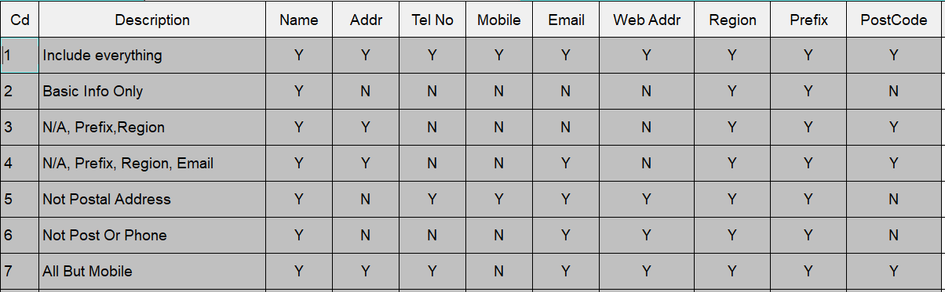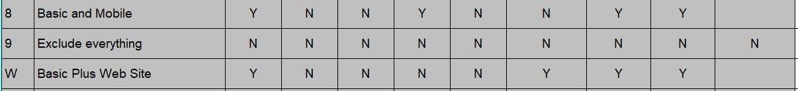

Signed / Arwyddyd: …………………………………….………………………………………………….…

Date / Dyddiad : ………………………………………………………………………………………………….

